Apartment Complex Management System

Project goal: Manage apartment rental information, including apartment units, tenants, and rental status.

Technology stack used: List the tools and technologies used (such as MySQL, Java Spring Boot, HTML, JavaScript, CSS, etc.)

GitHub Link:

E/R Diagram：

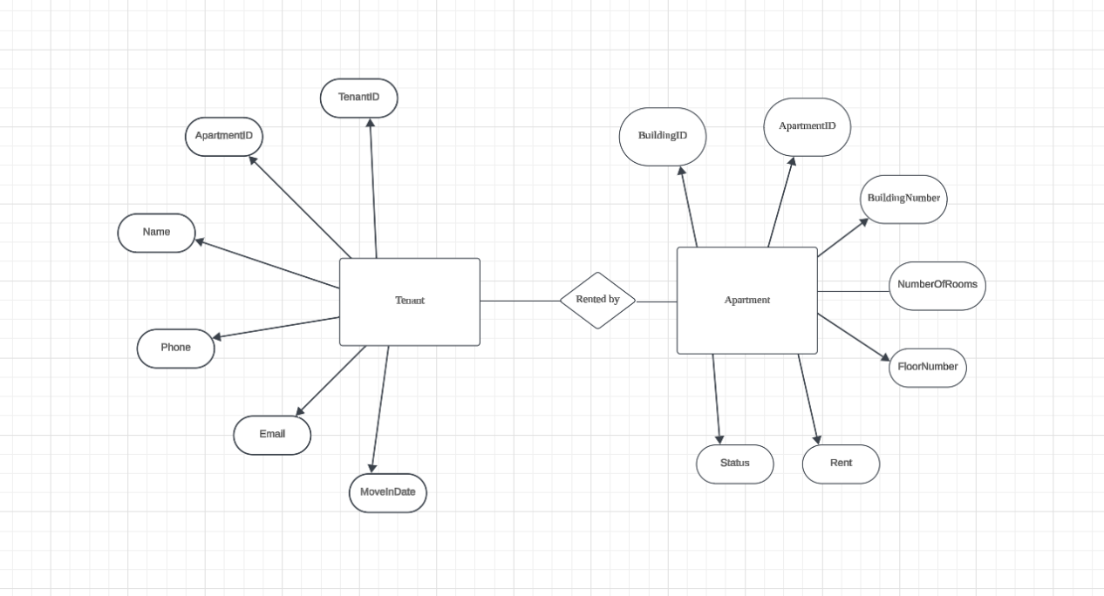

Database schemas:

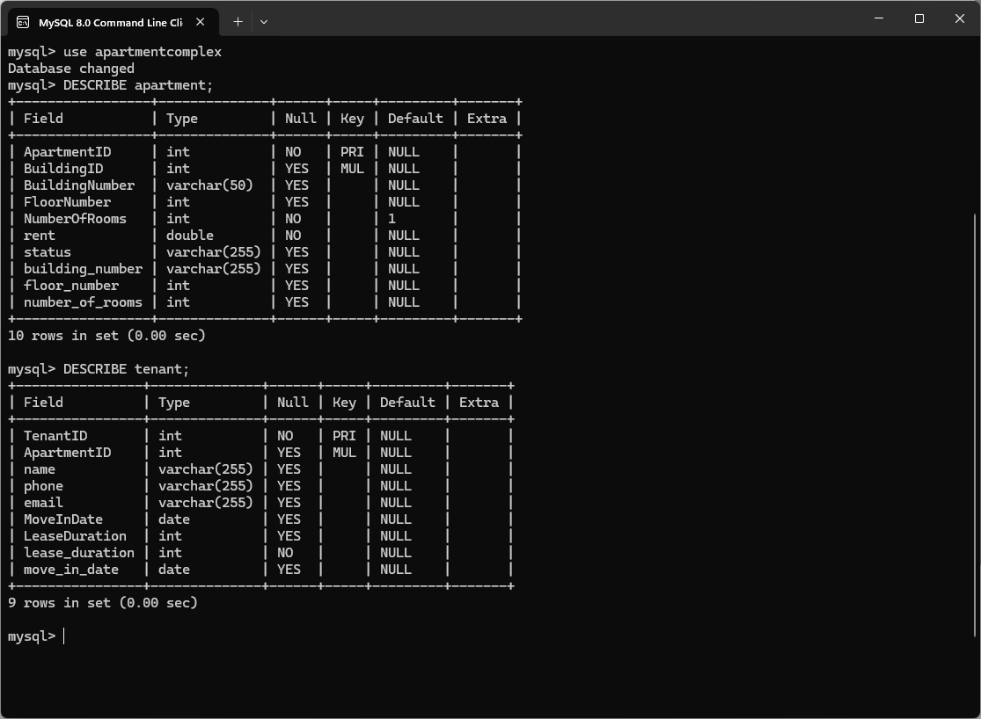

The following is the request sent through Postman and the json information received:

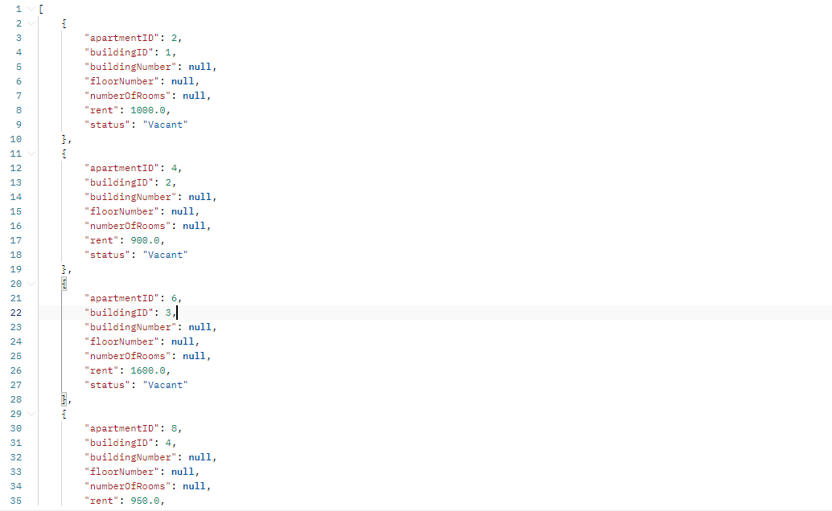

Make it accessible through the web through front-end tech:

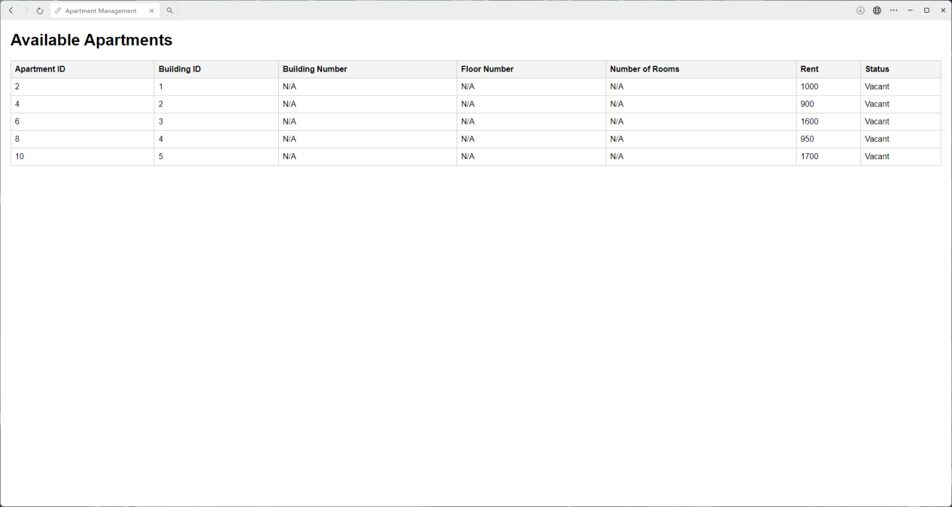

Finally, fill in the missing data:

